Chapter I

The Problem and it’s Background

Introduction

A Inventory Management provides a particular goods to be promoted have determined , the next step is to decide on the source of the sources of goods/product goods , brand , quality , and prices of the goods should be carefully considered. The desired mark ups and mark downs of the product should be considered in obtaining the selling price of the goods to be promoted. In the case of simulative sales , price should be considered as to make the goods to be bought. The people in the community constitute the market for goods and services. In motivation research which involves the analysis of the motives , attitudes , and thinking of consumers , the subconscious reason for buying certain products and specific brand at a particular time and place is discovered. Projective techniques are use to prove into the consumes hidden attitudes , preference , feelings , motivation , dislike , and prejudice.

Background of the Study

The Ragit's Burger Shop is a family owned business that is located at Irene cor. Belmar St. Miramonte Subdivision, Lucban, Quezon. It was founded in the year 2007, headed by a married couple with their three children. This shop entices its customers with a wide variety of easy to pick-up foods such as burger and fries, and an array of street foods. Other these said foods, they also offer some rice meals on the go.

The location of the shop is quite ideal due to its close proximity with the local State University and a private High School. Its patrons are usually the students that attend those aforementioned schools.

The shop maintained its reputation by providing a clean foods and a welcoming service. Thus, a lot of customers come back to buy some more.Seeing the popularity of the said shop, the researcher came up with the idea of monitoring the inventory of stocks to ensure total profitable management.

This chapter presents the conceptual framework of the existing system and proposed system that was used in order to illustrate its paradigm. It also includes the view of related literature and studies that was gathered through researchers. Technical and operational terms as defined in definition of terms.

Significance of the Study

* Business Owners

Importance of the Inventory Management Systems. An inventory management system can help you manage your business’s inventory and stock items, keeping track of exactly where your assets are and what they’re worth. The system also analyzes your business’s inventory needs and can even automate your ordering.

* Students

This study will help students to guide them for making system (inventory system).

* Future Reseacher

Scope and Delimitation

* Make accessible inventory management

The system is user friendly and can be access easily.

* VB.NET will be used for system structure

The application used in making our system (RIMS) is VB.NET.

* Mysql database is used

The database used in making our system (RIMS) is Mysql.

Statement of the Problem

The difficulty of making the RIMS (Ragit’s Inventory Management System)

Specific Problem

The following are the specific problems:

1. Incorrect placements in inventory items
2. Inaccuracy in updating the system
3. Lack of optimization

Objectives of the Study

The main objectives of the study is to develop user friendly system that would replace the manual system activities.

Specific Objectives

The following are the specific objectives of the study:

1. Create an edit and update function in the system
2. To provide a organized products information
3. To collect/provide sufficient data

Definition of Terms

The following terms are the technically and operationally defined in the context of the study.

Inventory. An itemized catalog or list of tangible goods or property , or the intangible attributes or qualities.

Inventory Management. A component of supply chain management , inventory management supervises the flow of goods from manufacturers to warehouses and from these faculties to a point of sale. A key function of inventory management is to keep a detailed record of each new or returned product as it enters or leaves a warehouse or a point of sale.

Product. A good , idea , method , information , object or service created because of a process and serves a need or satisfies a want. It has combination of tangible and intangible attributes (benefits , features , functions , uses) that a seller offers a buyer for purchase.

System. Refers to a set of rules that governs behavior or structure is a set of interacting or interdependent entities forming an integrated whole.

SQL. Referred to as Structured Query Language , is a database computer language designed for managing data in relational databases , management systems (RDBMS) and originally based upon relational alge

**Conceptual Framework.** Used in research to outline possible courses of action or to present a preferred approach to an idea or thought.

**Data.** It refers to qualitative or quantitative attributes of a variable or set of variables.

**Data Flow Diagram.** A graphical representation of "flow" of data through out an information system

**Hardware.** Component devices which are typically installed into or peripheral to a computer case to create a personal computer upon which system software is installed including a firmware interface such as a BIOS and an operating system which supports application software that performs the operator's desired functions.

**Information.** Any kind of event that affects the state of a dynamic system.

**Inventory**. A list compiled for some formal purpose, such as the details of an estate going to probate, or the contents of a house let furnished.

Sales- the act of selling a product or service in return for money or other compensation.

**Software**. A conceptual entity which is a set of computer programs, procedures, and associated documentation concerned with the operation of a data processing system.

**System**. A set of interacting or interdependent components forming an integrated whole.

**SDLC (**System Development Live Cycle**).** A process of creating or altering information systems, and the models and methodologies that people use to develop these systems.

**TPS** (Transaction Processing System). A type of information system that collects, stores, modifies and retrieves the data transactions of an enterprise.

Chapter II

REVIEW OF THE RELATED LITERATURES AND STUDIES

Review of Related Literature

In the article entitled “Reason for using an Inventory” (Beck, Kent and Martin Fowler , February 2001) stated that an effective and efficient trip to the inventory begins with a good list and a budget. The customers will proceed on some systematic path by choosing the products in the list , checking the price , reviewing the other offerings as well. Because of the way software development works , software testers do not usually get want really customers really want in buying. All experts agree that using a proper listing of variety of products so that they can easily decide what products they want to buy. Using a list helps minimize the mistakes that something we can make because something was forgotten , and it reduces the waste of unnecessary purchases. How good list is depends on how carefully the cupboards reviewed during preparations.

Foreign Literature

According to Kj Henderson, they have a three major advantages by using of inventory system these are (Time savings, Accuracy, and Consistency) which helps a lot for a businessman to increase the sales of their business.

**Data Collection for Decision Making.** Using this type system, a company makes strategic business decisions regarding raw material purchases, production scheduling, pricing, logistic and other decisions in the supply chain. Sales and Inventory data enables the company to increase or decrease productions in the factory so the company won’t have too many finished goods stored in its warehouse.

**Local Literature**

According to PLDT (Manila,Philippines,April 15,2011), small and medium enterprises, who long for a point-of-sale(POS) system that can track how much they sell and how much stock they have left at their stores in real-time and from anywhere, can now turn to PLDT SME Nation.

An article by Junaito Villegas (June 23, 2009) entitled “Inventory controls are key to dissuade employees from stealing” states that:

“Computers can only do much, but coupled with inculcating honesty among staff and instituting the appropriatedeterrents, they can work very well in minimizing losses and pilferages. It is therefore highly advisable to do both the manual and the computerized inventory system in a retail and wholesale business.”

Josefina Estolas in the book Fundamentals of Research (2009), in exploration, we find new techniques, knowledge, even developed new substances, gadgets, equipments, processes or procedures, imagination and skill is employed by the researcher. The commodities, new devices, services, in technology are needs of man for a better fuller life which is concern of the research. These useful arts are the product of the technological environment and the end-user is society in general.

Review of Related Studies

This presents both of foreign and local studies. Informations were gathered in other dissertations and research projects in the internet and schools.

Foreign studies

According to a recent Aberdeen Group study(March 2012), companies are prioritizing supply chain visibility, inventory optimization, supply chain analytics, and supply chain outsourcing as ways to cut supply chain management (SCM) costs this year.

According to IBM(October 2012) Innovations such as just-in-time manufacturing bar codes and RFID tags have revolutionized supply chain management. Unfortunately these innovations have brought with it staggering amounts of data to deal with. This white paper outlines some of the major factors affecting inventory and supply chain management.

Local Studies

According to J.De Leon and M. Ferrer (2009) Under the Koread Red Ginseng Enterprise Sales and Inventory System, the researchers came up with a computerized sales and inventory system. The proponents used database to easy access of files and for easier and faster processing of the selling and inventory transaction. The program was designated to generate reports such as monthly reports, inventory reports, sales invoice and list of items.

Based on the research entitled “Computerized Sales and Inventory system for Ronmon Trading” (de Alday, Espino, Ragudo), 2010, the replacement of the manual system with the proposed system provided more efficient and accurate processing of transaction. The said system is much reliable, eliminated errors and inaccurate information, and provided valuable reports with integrity.

Also stated in the research, “Sales and Inventory System For Schema Megacenter” (Almeda, Dañez, Geronimo), the proposed system are not just only accurate, realiable, and fast in processing transactions rather it is also provided more systematic way of transacting with the members and through the billing system also helped the employees to save a lot of time on transaction processing.

Based on the research entitled “Computerized Sales and Inventory system for Ronmon Trading” (de Alday, Espino, Ragudo), 2010, the replacement of the manual system with the proposed system provided more efficient and accurate processing of transaction. The said system is much reliable, eliminated errors and inaccurate information, and provided valuable reports with integrity.

Also stated in the research, “Sales and Inventory System For Schema Megacenter” (Almeda, Dañez, Geronimo), the proposed system are not just only accurate, reliable, and fast in processing transactions rather it is also provided more systematic way of transacting with the members and through the billing system also helped the employees to save a lot of time on transaction processing.

In the study entitled “Osaka Sales and Inventory System” (Laranang, Maaño and Nañola, 2009) states that business nowadays takes the advantage of using modern technology to improve their status and ensuring an efficient and newer way to make their work easier. They state that the main problem of the Osaka Iridology is what modern effective tool must be use in creating and developing a sales and inventory system that will manage efficiently their transaction. So they develop a system that inclusively for the transaction of Osaka Iridology, such as monitoring of their medicine and their daily sales.

Conceptual Framework

This conceptual framework of the study illustrates the paradigm used using Input – Process – Output (IPO Diagram).

OUTPUT

PROCESS

INPUT

RIMS (Ragit’s Inventory Management System)

Inventory Management

Checking and Debugging

Figure 1 The IPO of the Proposed System

Figure 1 shows how the proposed system works. The system works by manually inputting the employees information and product information. It will process the proposed system using the main form which you can select what specific transaction and the customers services. The proposed system works on how the customers decide want to buy the specific product they want and provide the system and give them the right price listed in it. It also allow the customer to choose a variety drink products. And give also a rate on how they enjoyed the customers service provided.

Chapter III

METHODOLOGY AND SOFTWARE DESIGN

This chapter presents the method of research used; the methods used in developing the software and methods used in products evaluation is also included to discuss how the system was evaluated.

Methods of Research Used

The methods used in Ragit’s Inventory Management System (RIMS) is VB.NET for the system structure.

Methods Used in Developing the Software

This part represent the methods use of the proposed system in developing the software for Inventory Management. Thus they use System Development Life Cycle (SDLC). It is a phase approach to analysis and design that holds the system that is best developed through the use of specific cycle of analyst and use activities. The software development life cycle (SDLC) is a framework defining tasks performed at each step in the software development process. SDLC is a structure followed by a development team within the software organization. It consists of detailed plan describing how to develop , maintain and replace specific software. The life cycle defines a methodology for improving the quality of software and the overall development process.The software development life cycle is also known as the software development process.

Question Proper:

**INSTRUCTION:** This questionnaire aims to determine the effectiveness and efficiency of the proposed system. Please provide your honest opinion by putting a check mark (/) to indicate the extent of your agreement and disagreement for the following statements.

**5 – EXELLENT 4 – VERY GOOD 3 – GOOD 2 – FAIR 1 – POOR**

|  |  |  |  |  |  |
| --- | --- | --- | --- | --- | --- |
| **Questions** | **5** | **4** | **3** | **2** | **1** |
| **RELIABILITY** |  |  |  |  |  |
| 1.The system guides the user on how to use the online system by  the use of graphical user interface (GUI) environment. |  |  |  |  |  |
| 2.The system displays error message if the user enter invalid information. |  |  |  |  |  |
| **ACCURACY** |  |  |  |  |  |
| 1.The user has the capability to view the system anywhere and anytime. |  |  |  |  |  |
| 2.The researcher has the capability to edit and update the inventory system. |  |  |  |  |  |
| **EASE OF USE** |  |  |  |  |  |
| 1.The design of the system and website is user friendly. |  |  |  |  |  |
| 2.Do purchasing personnel specialize in a product category which they acquire goods? |  |  |  |  |  |
| 3. The system consists of a transaction form for the product purchase information. |  |  |  |  |  |
| **SECURITY** |  |  |  |  |  |
| 1.In system, the user information and result of the product order are secured. |  |  |  |  |  |
| 2.The product ordered by the user cannot be edited if it is submitted already. |  |  |  |  |  |

**Statistical Tool**

Statistics is one way of getting the information organized. This also includes the scaling system, which was used by the reseachers as a technique to determine the respondent’s interpretation of facts. The Likerts scale was used to interpret items in the questionnaire. The range and interpretation of the five point scale are shown on the table.

|  |  |  |
| --- | --- | --- |
| **SCALE** | **RANGE** | **INTERPRETATION** |
| **5** | **4.6 - 5.0** | **Excellent** |
| **4** | **3.7 - 4.5** | **Very Good** |
| **3** | **2.8 – 3.6** | **Good** |
| **2** | **1.9 – 2.7** | **Fair** |
| **1** | **1.0 – 1.8** | **Poor** |

Identifying Problems , Opportunities and Objectives. The existing system is evaluated and problems are identified. The proponents identified the main problems experienced by Inventory Management System with regards to the present system being used through interviewing the primary uses of the system , as well as carefully observing and closely examining the whole operation. In the first phase of the system development life cycle , checking the products that could be available. Through checking the products , it may provide the available products in the system. They were having hard time on checking the remaining items , purchased products , and their transaction system in every customers transact in availing products. And also in monitoring/checking the employees attendance and computing the payroll of each employees.

Analyzing System Needs. During this phase, the proponents themselves determine what appropriate hardware specification must need by the system. And what must be done to overcome the problems about the proposed system by analyzing the system needs such as the hardware to use in the system.

Developing and Documenting Software. In this phase the proponents started to develop the software needed for Inventory Management System. Serve as guide to the customers and the user about the proposed system. And in developing software by handling some difficulties and some problems encountered in the system. The proponents design , code , and removed syntactical errors from computer programs to ensure quality.

Testing and Maintaining the System. In the phase the system must be properly tested , so that when the bugs and errors encountered it will be easily solve. Debugging and testing with the sample data may help analyze the proposed system and can be easily use. Maintaining the system is always the priority, when errors occurred such debugging during the implementation. It has an error handler to avoid termination of the system.

Implementing and Evaluating the System. As for the implementation of the system , it is best recommended that the end users must undergo to a properly training to the handle the system. It is essentials to make a few adjustments in the system , to ensure the smoothly performance of the system. The researcher also start testing it , explain how it properly works and how to use or operate the system.

Methods Used in Product Evaluation

The evaluation must find out the system’s performance and if the system satisfies all the objectives of the proponents to the customers who use the proposed system.

Debugging. To search for and eliminate malfunctioning elements or errors in the system.

Security. The software is secured. It is not easily operated outside of management system.

Syntactical Errors. An error in the syntax of a sequence of characters or tokens that is intended to be written in particular programming language. A program will not compile until all the syntax errors are corrected.

Testing. Meant to find defects in the code , or from different angle , and to prove the suitable level that may fit for the management system.

Chapter IV

INTERPRETATION AND ANALYSIS OF DATA

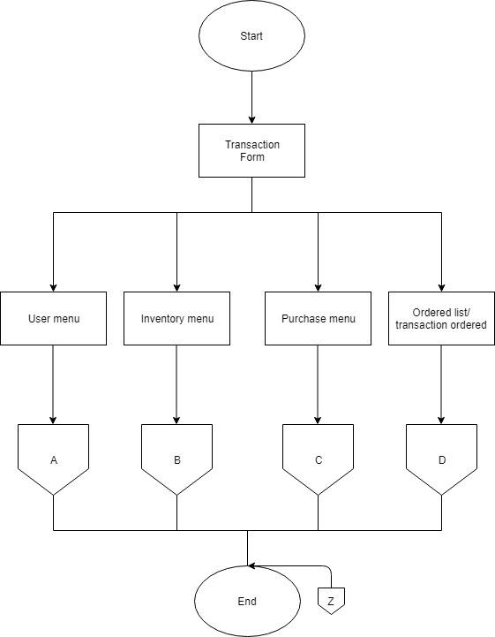

Figure 2 System Flow of the Update System

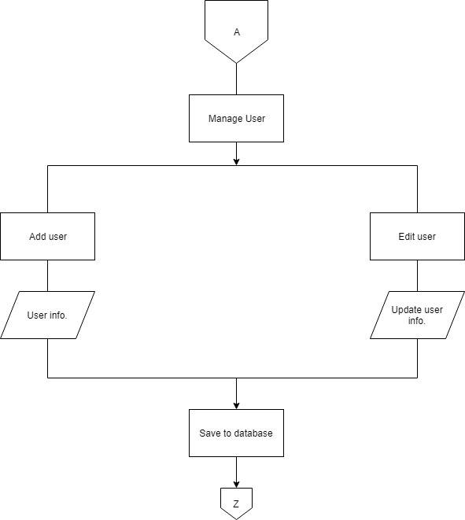

Figure 2.1 System Flow of the Update System

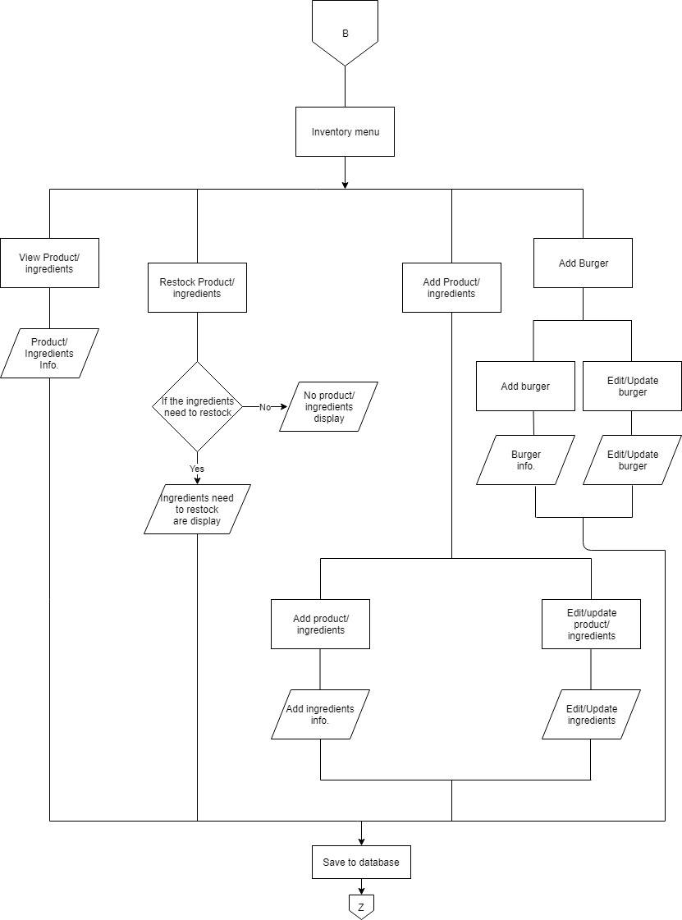

Figure 2.2 System Flow of the Update System

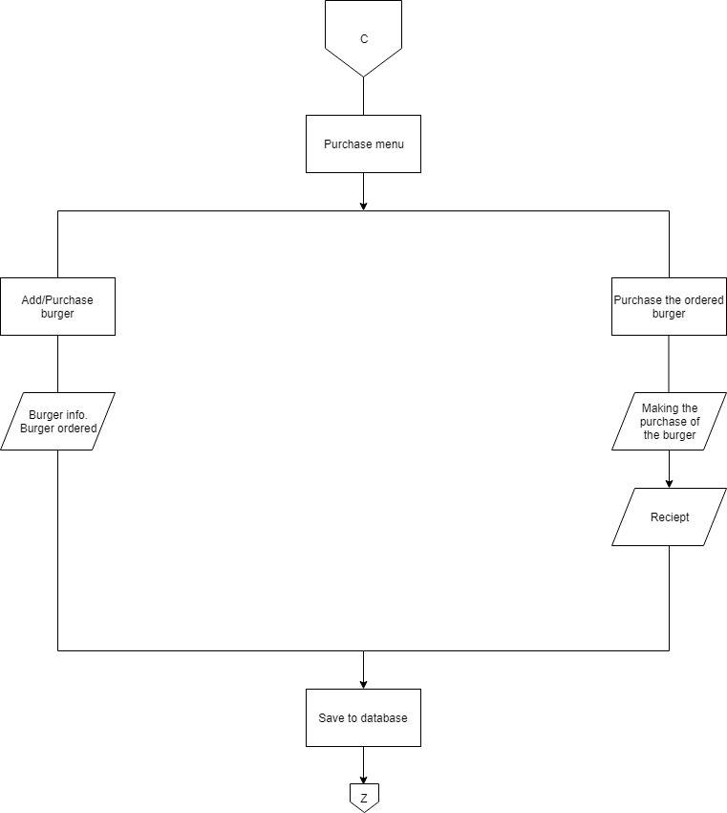

Figure 2.3 System Flow of the Update System

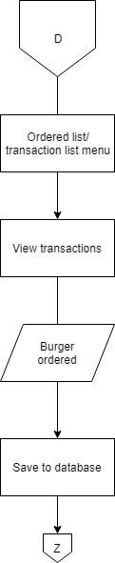

Figure 2.4 System Flow of the Update System

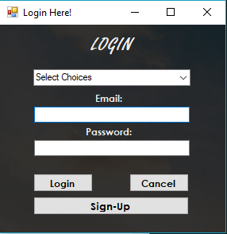

Login Form

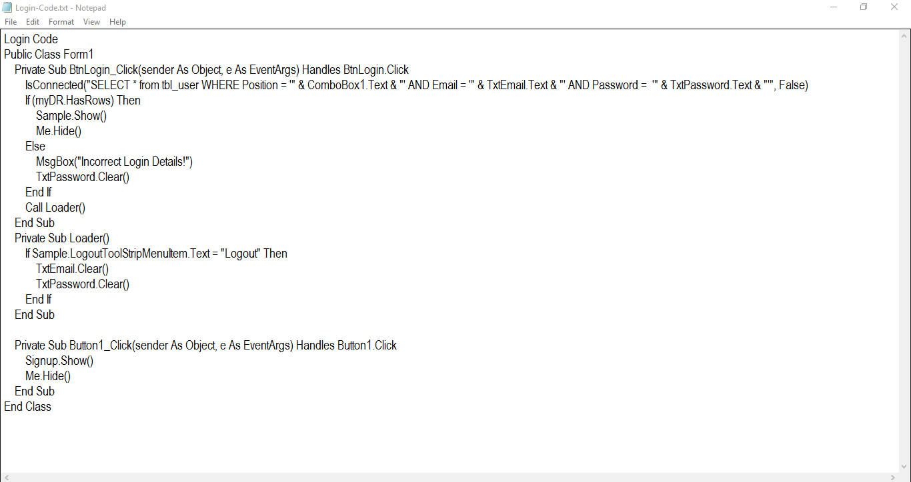

Login Code

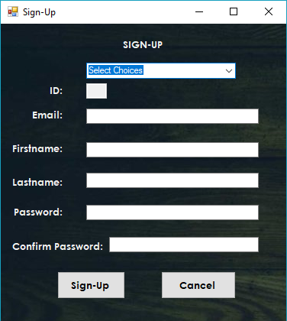

Signup Form

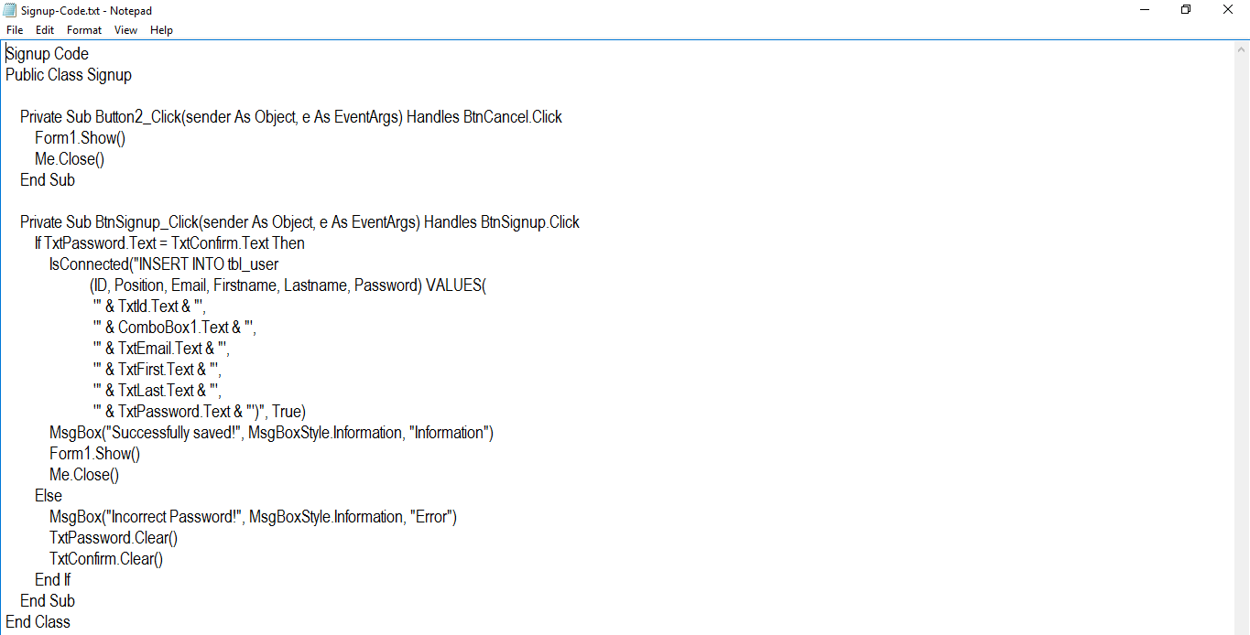

Signup Code

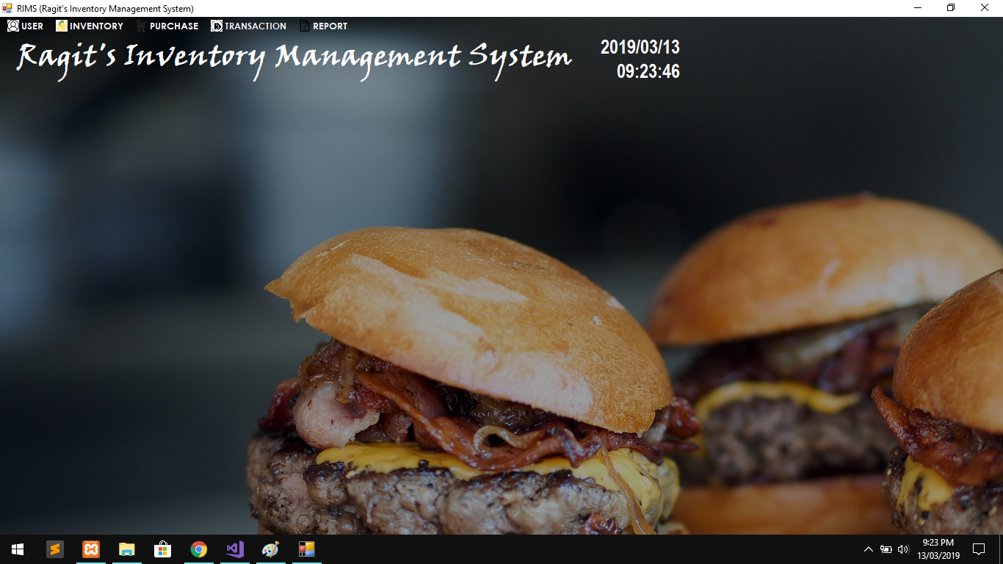

Main Form

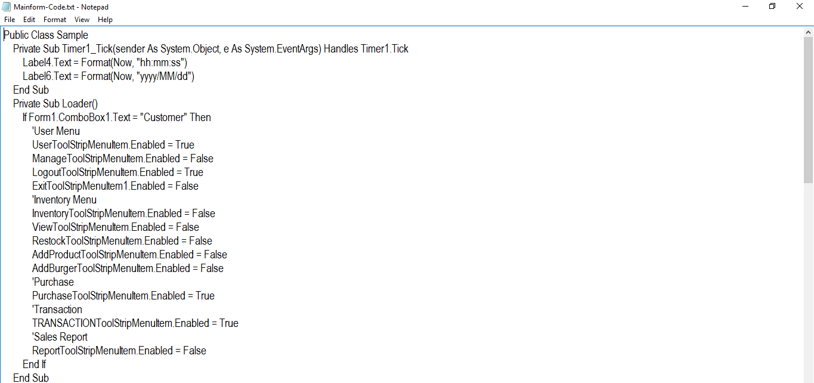

Main Form Code #1

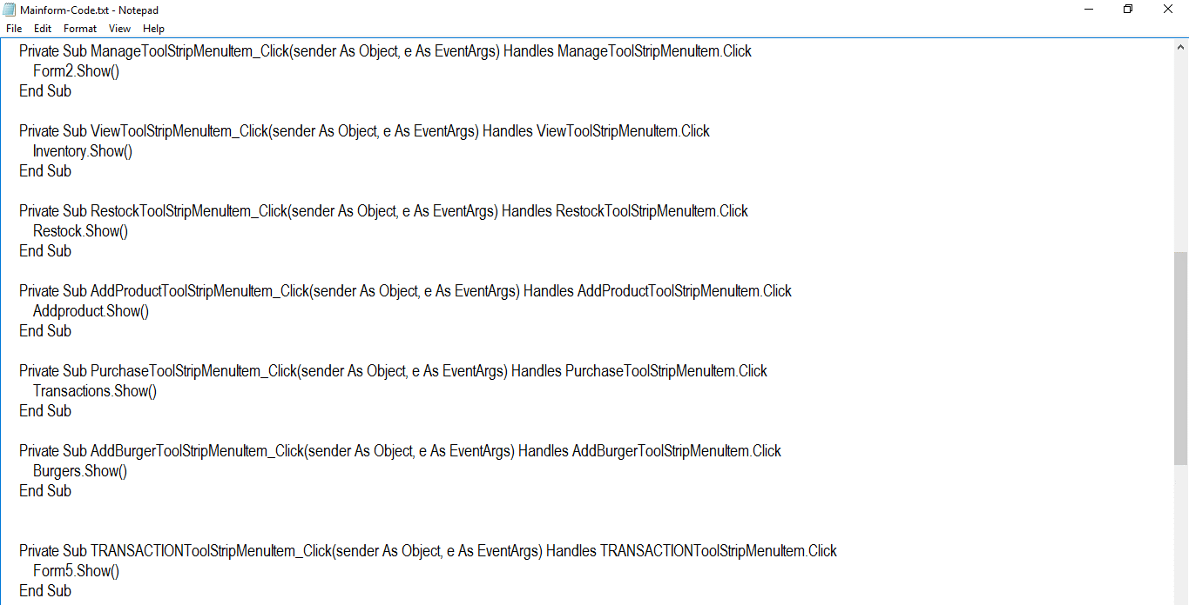

Main Form Code #2

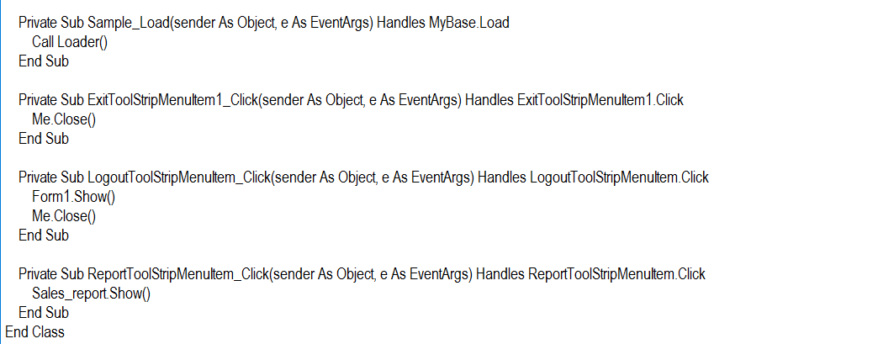

Main Form Code #3

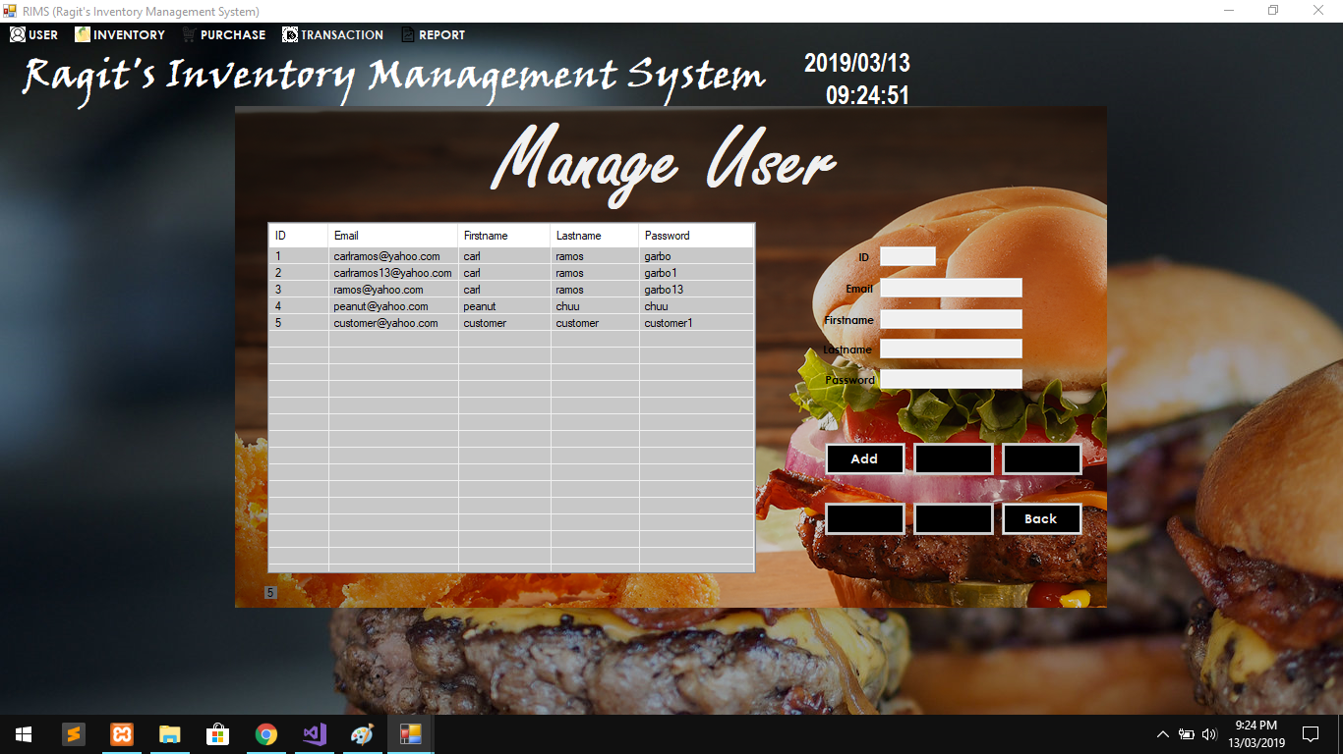

Manage User Form

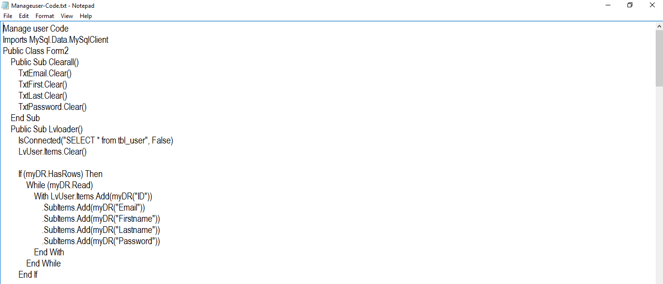

Manage User Code #1

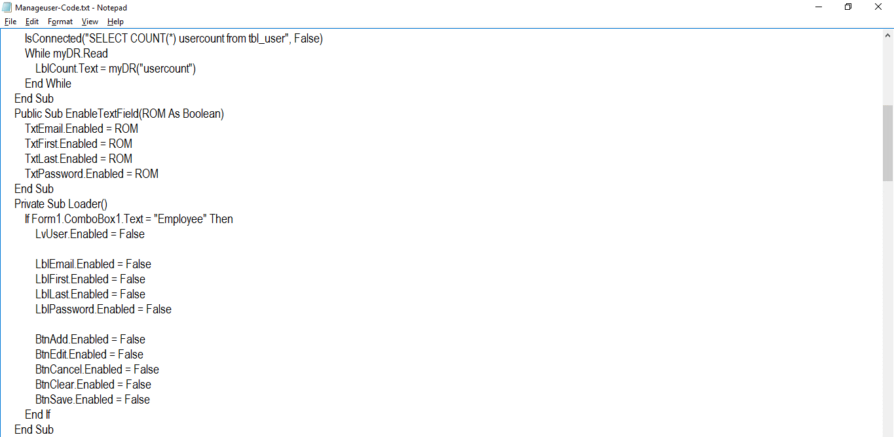

Manage User Code #2

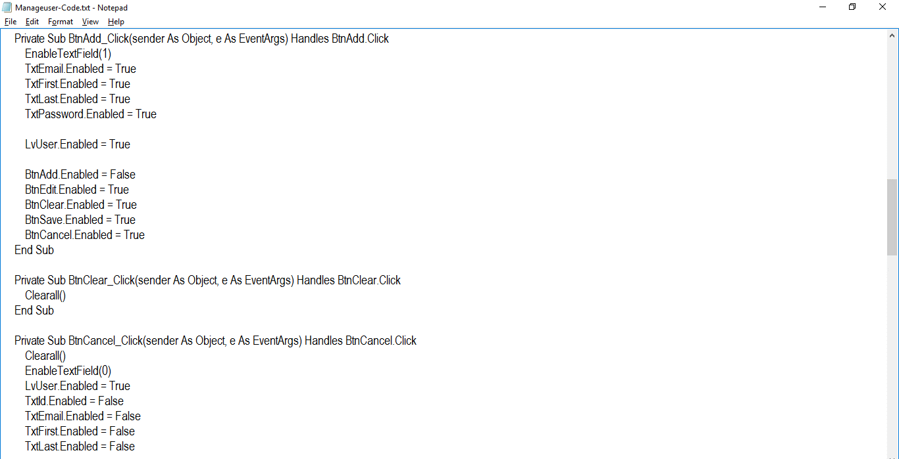

Manage User Code #3

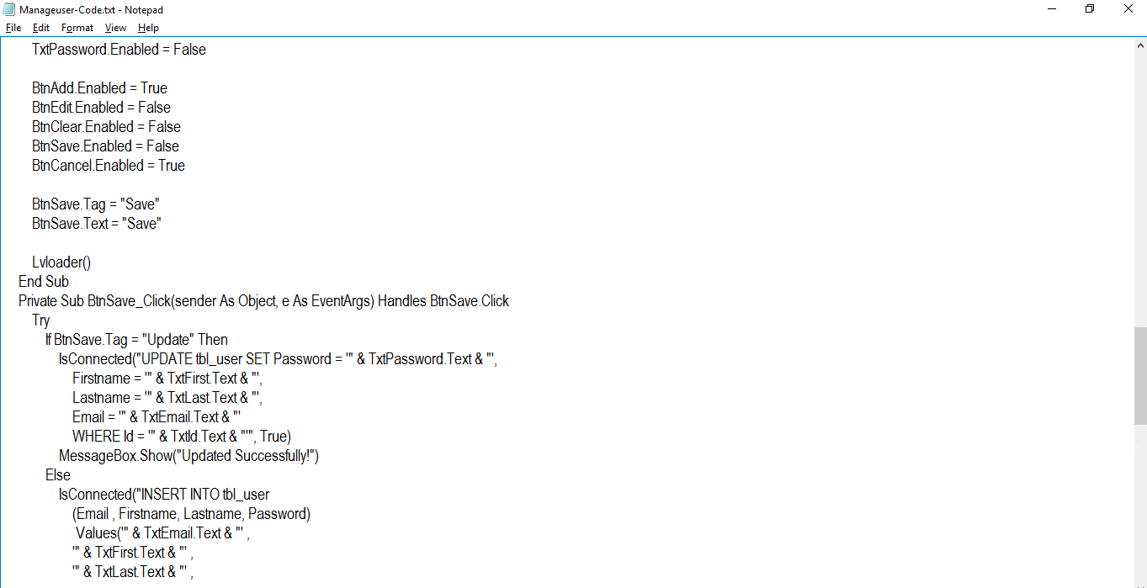

Manage User Code #4

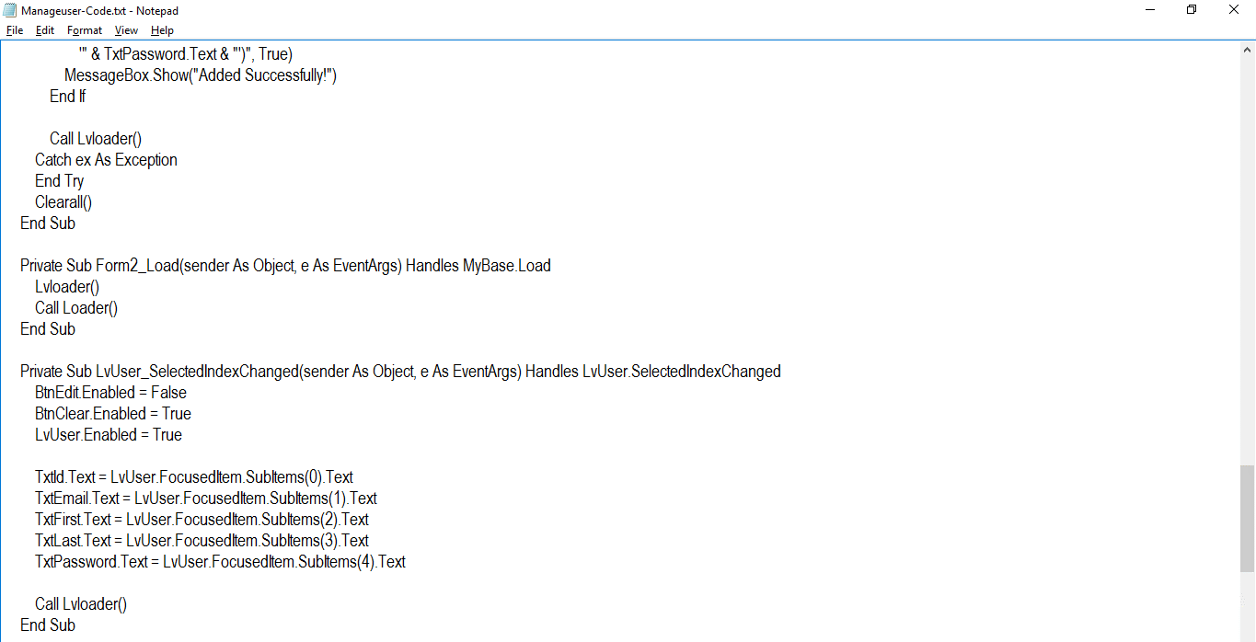

Manage User Code #5

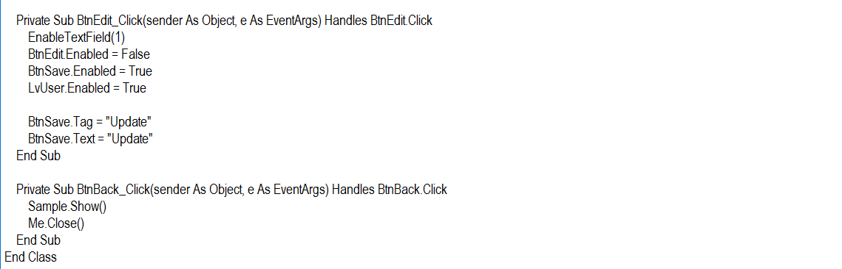

Manage User Code #6

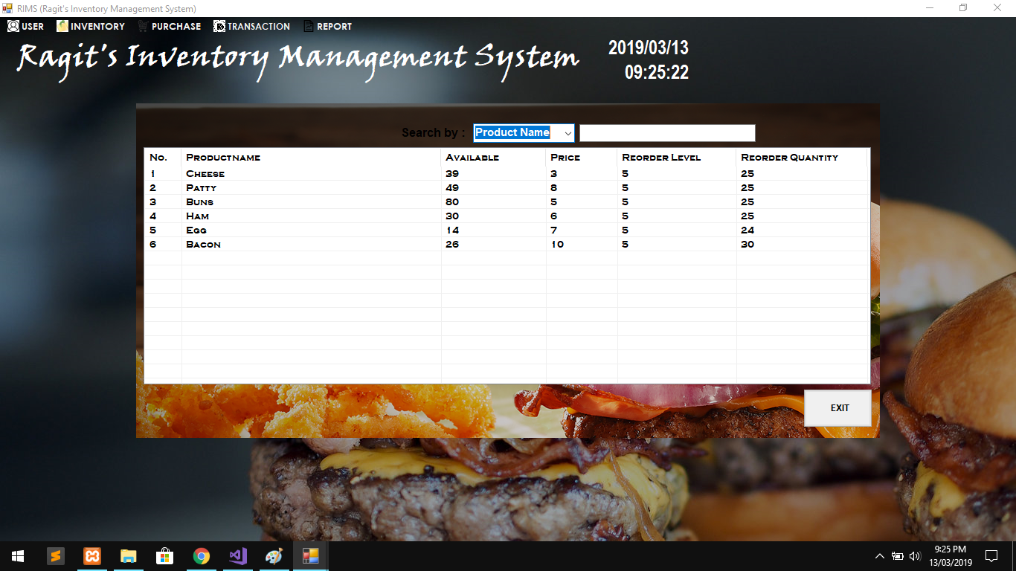

Inventory Form

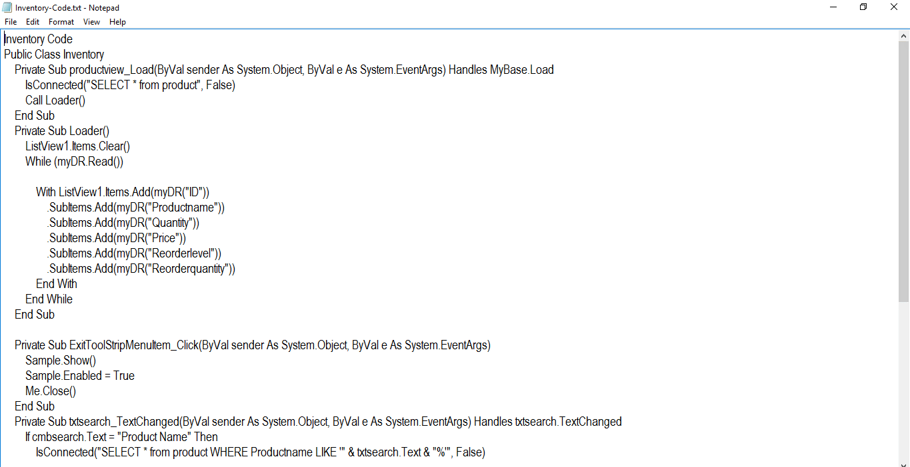

Inventory Code #1

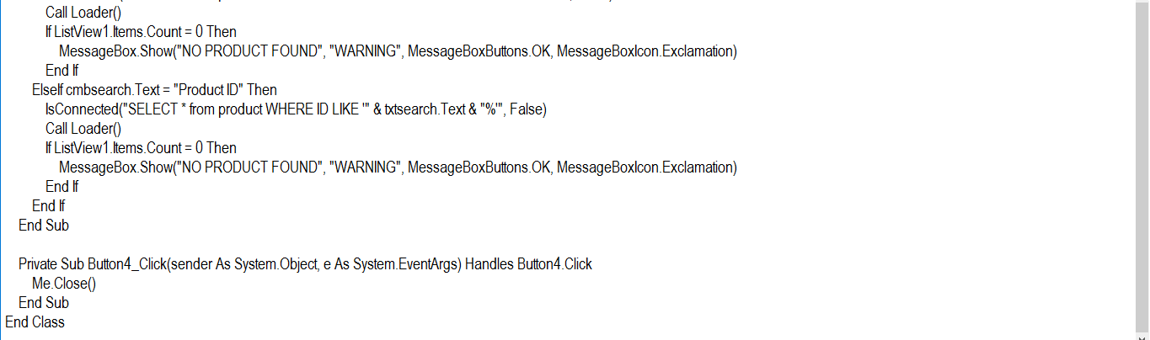

Inventory Code #2

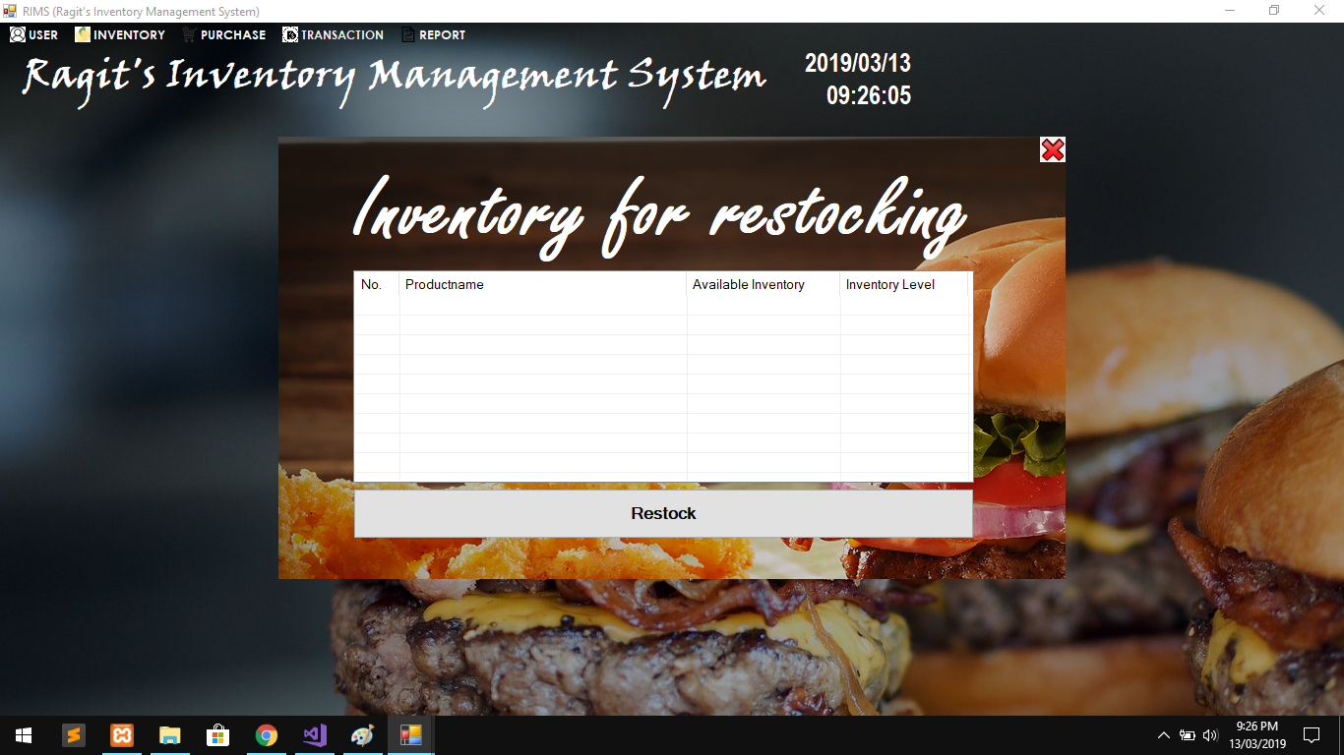Restock Form

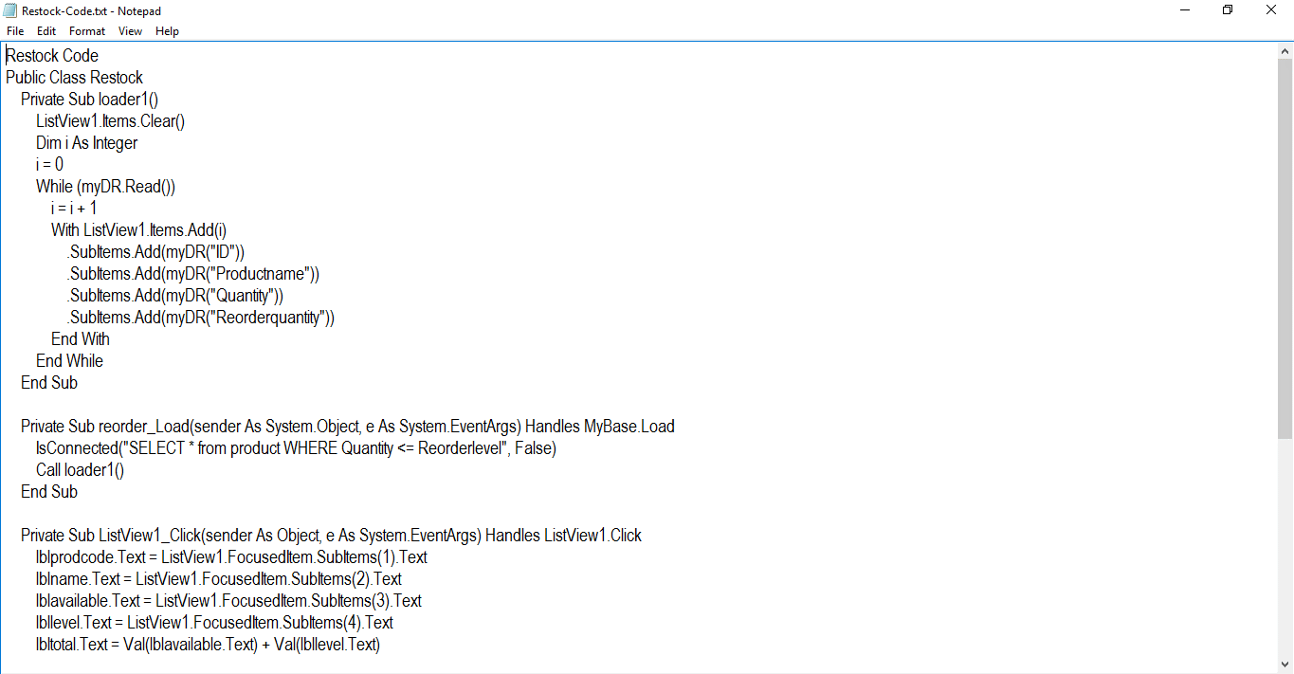

Restock Code #1

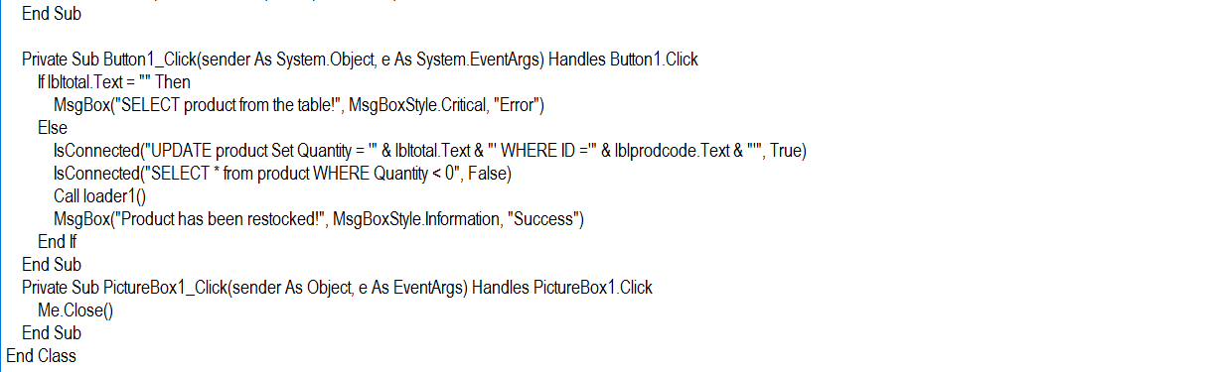

Restock Code #2

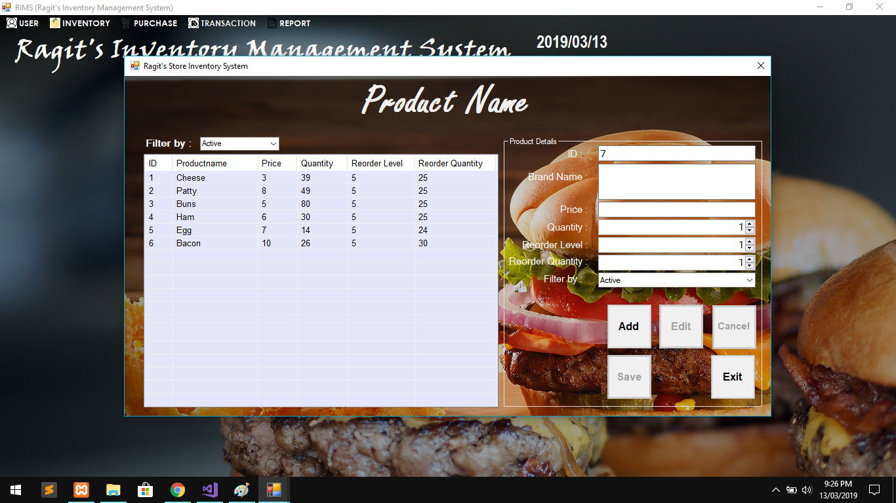

Add Product Form

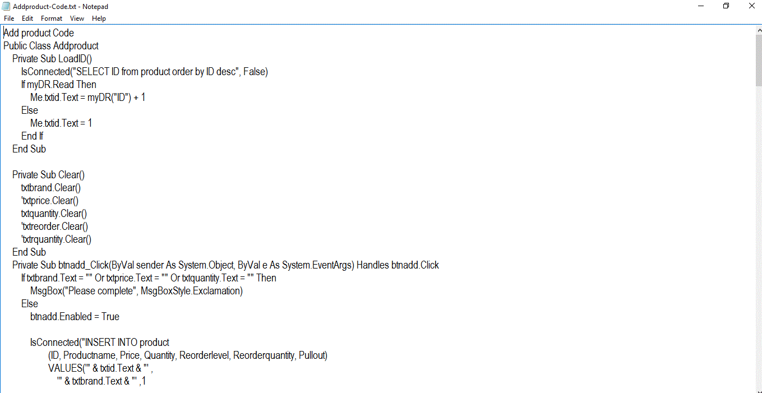

Add Product Code #1

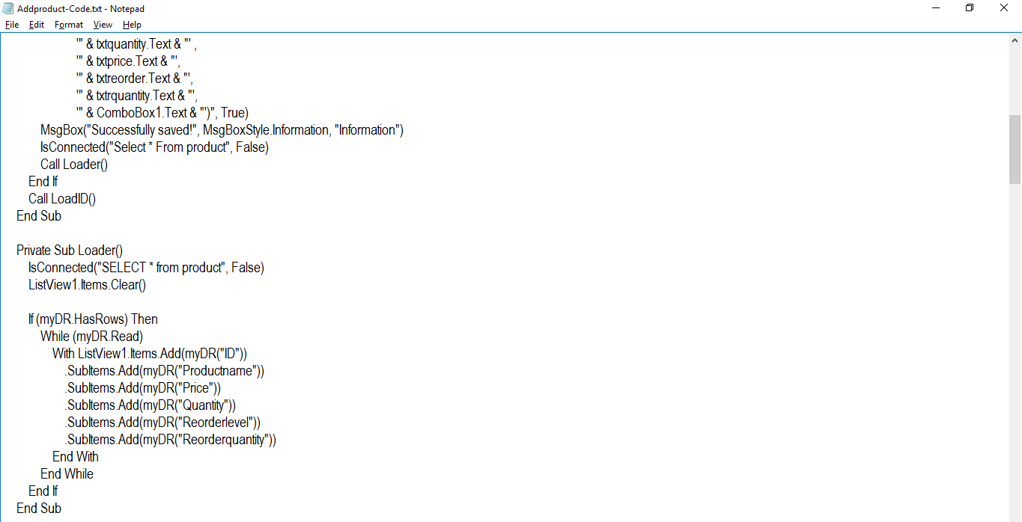

Add Product Code #2

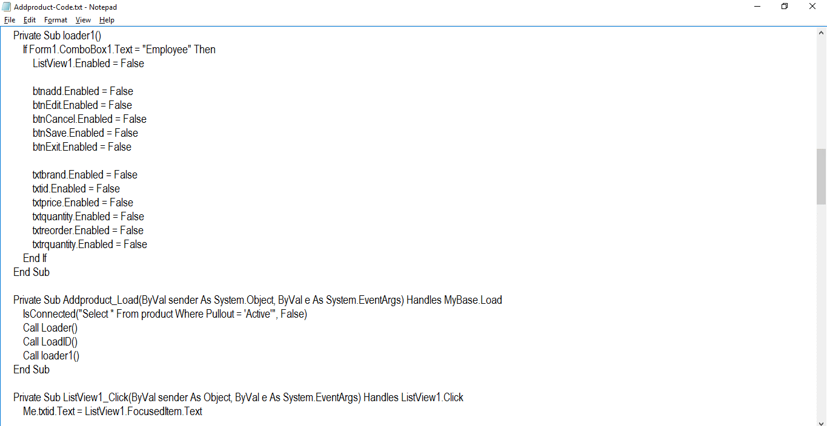

Add Product Code #3

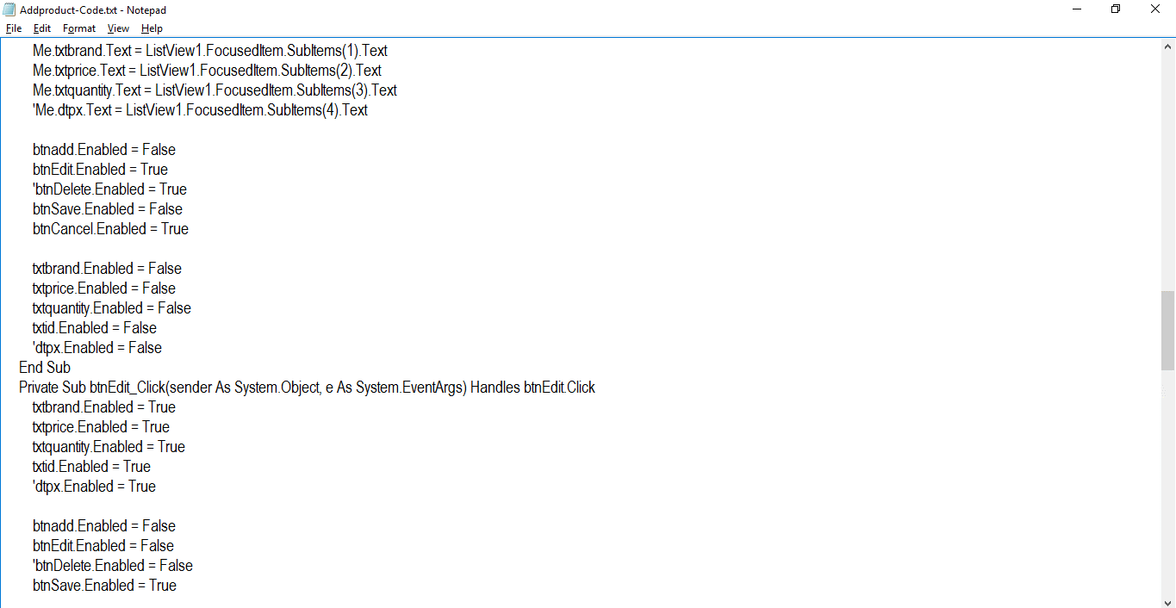

Add Product Code #4

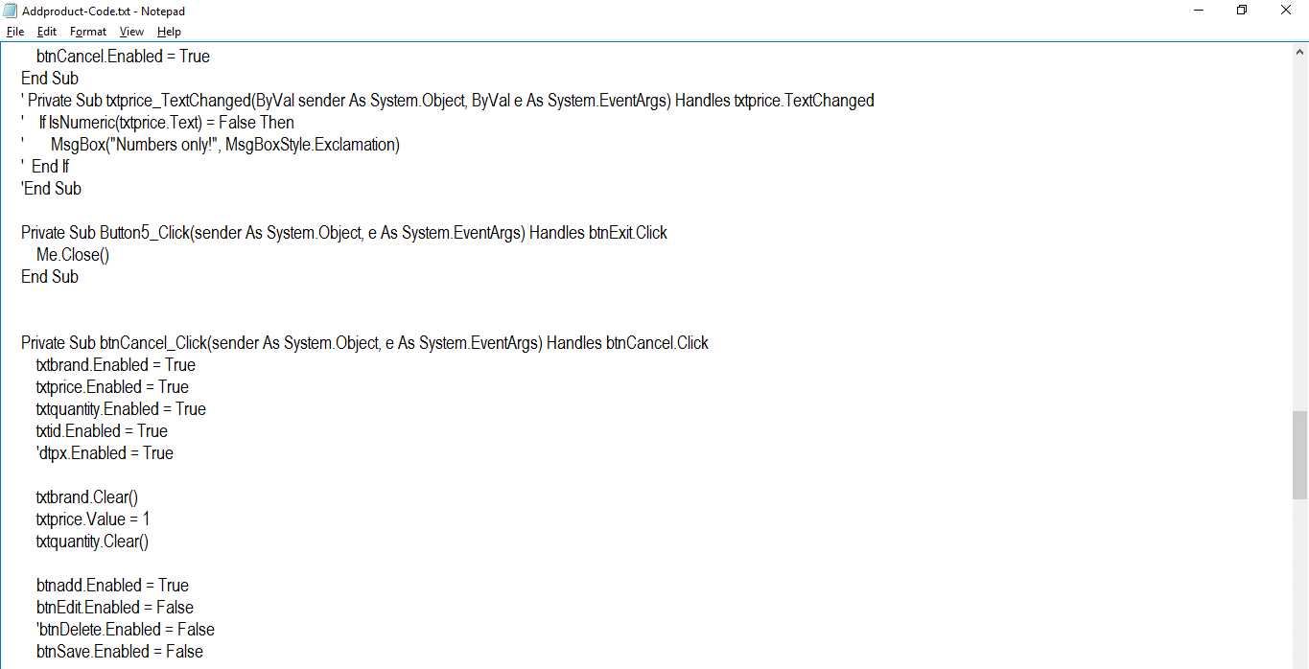

Add Product Code #5

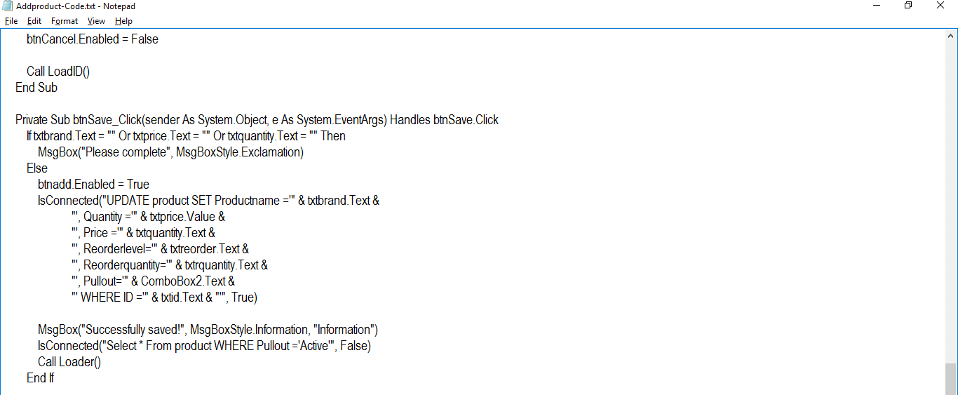

Add Product Code #6

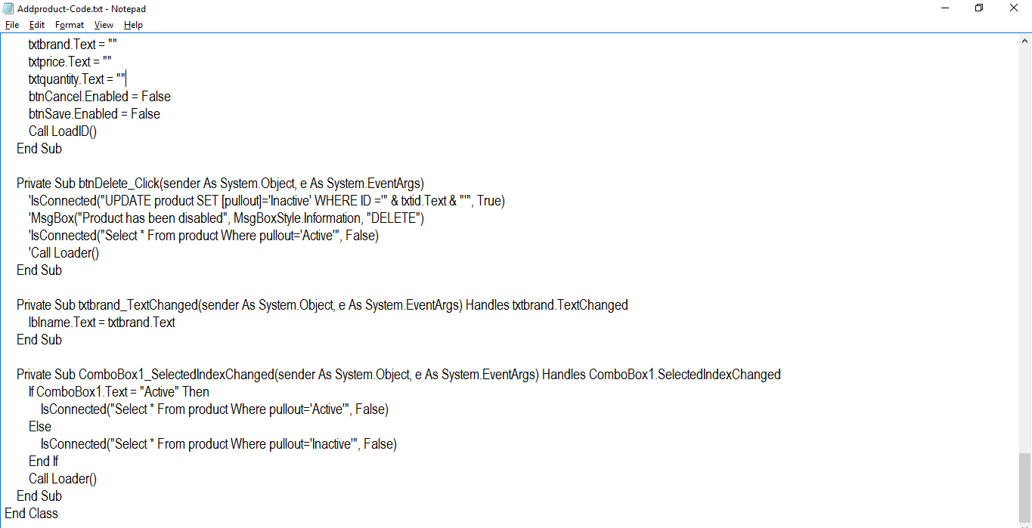

Add Product Code #7



Add Burger Form

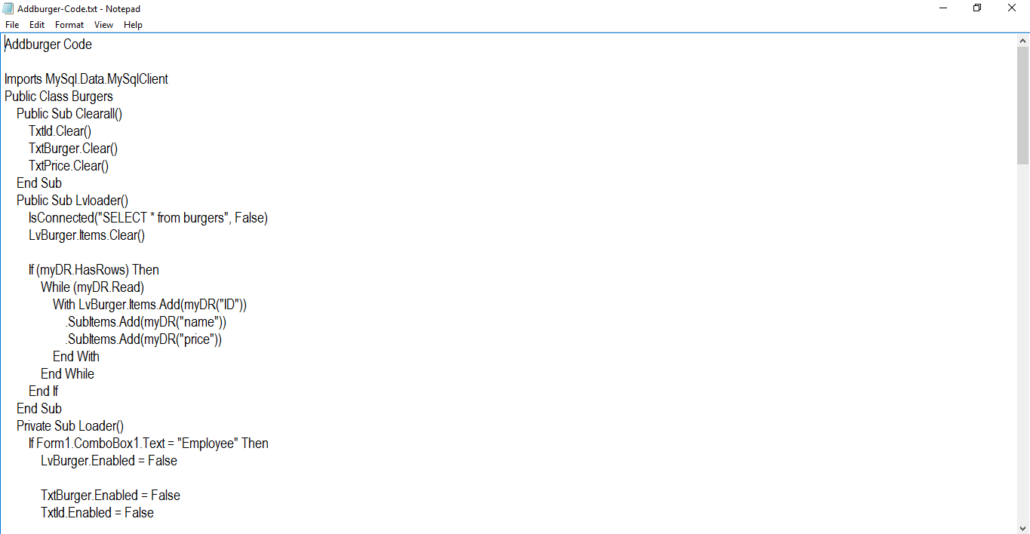

Add Burger Code #1

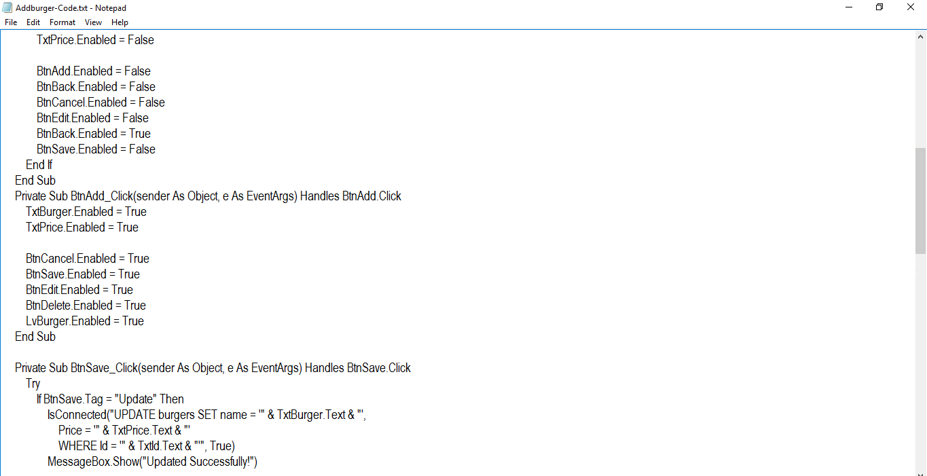

Add Burger Code #2

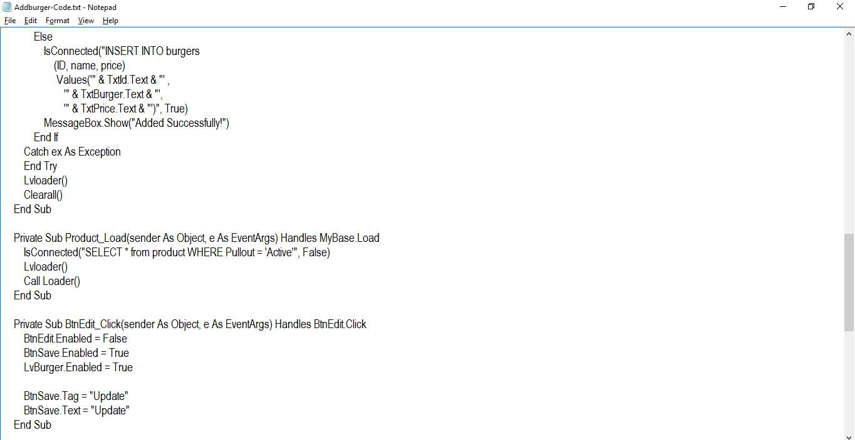

Add Burger Code #3

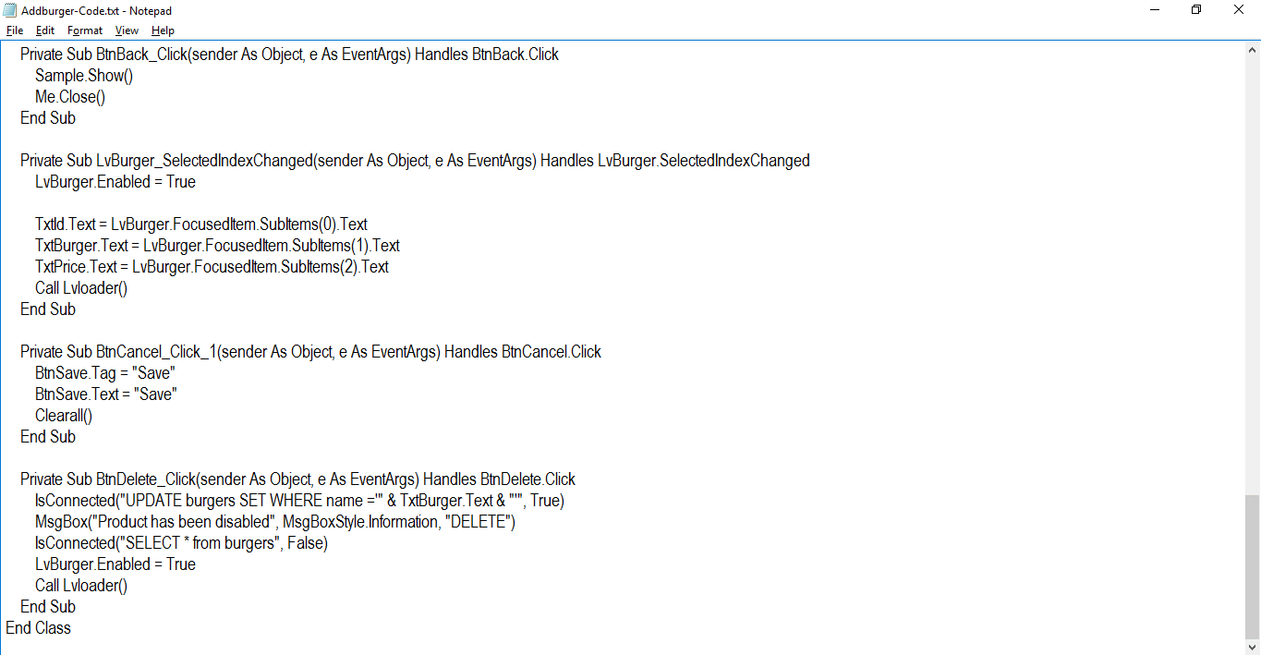

Add Burger Code #4

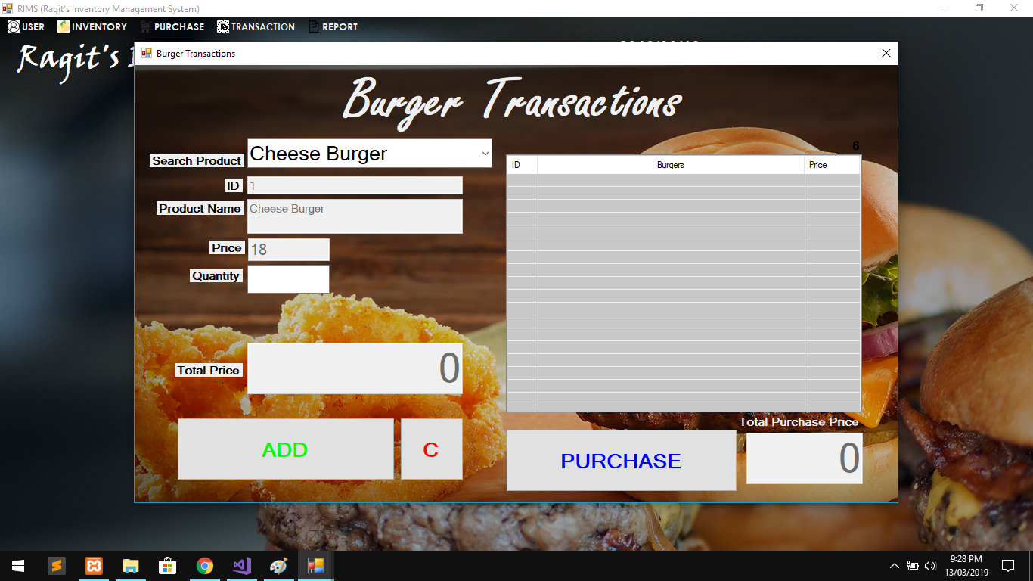

Purchase Form

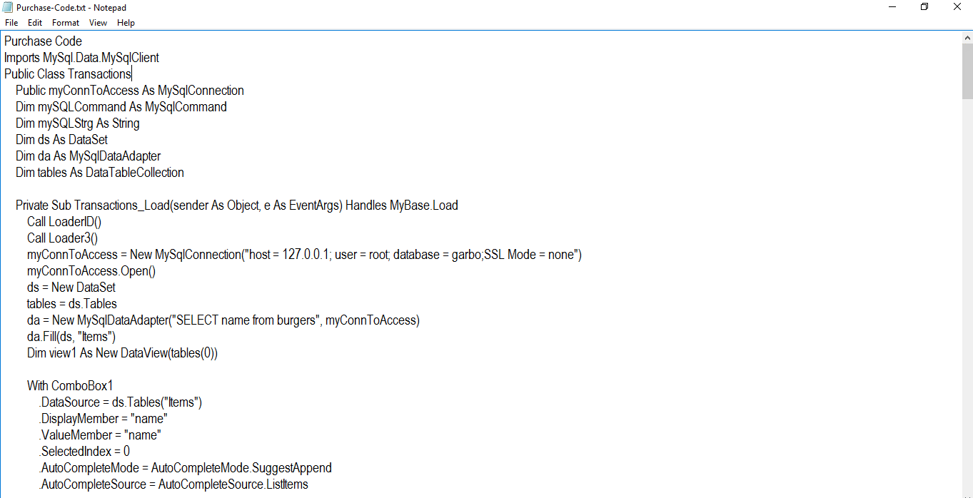

Purchase Code #1

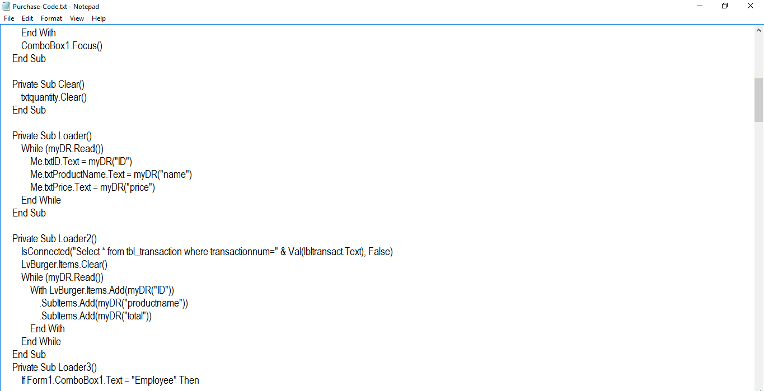

Purchase Code #2

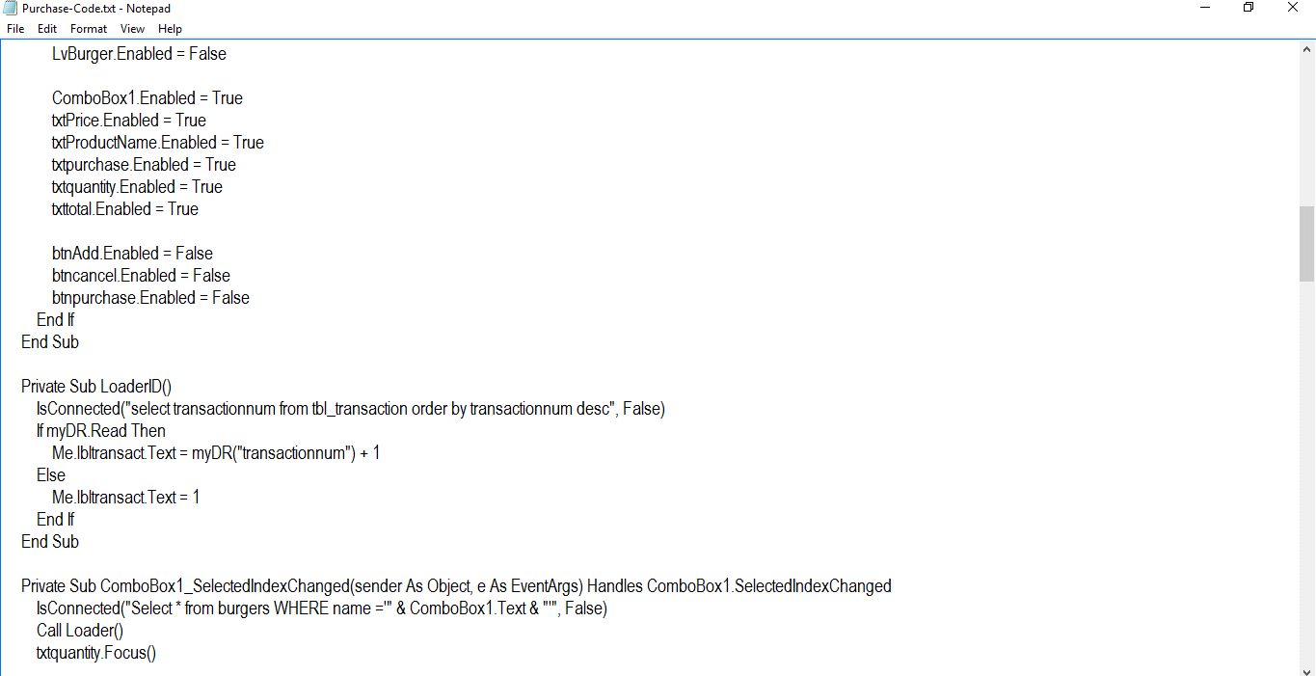

Purchase Code #3

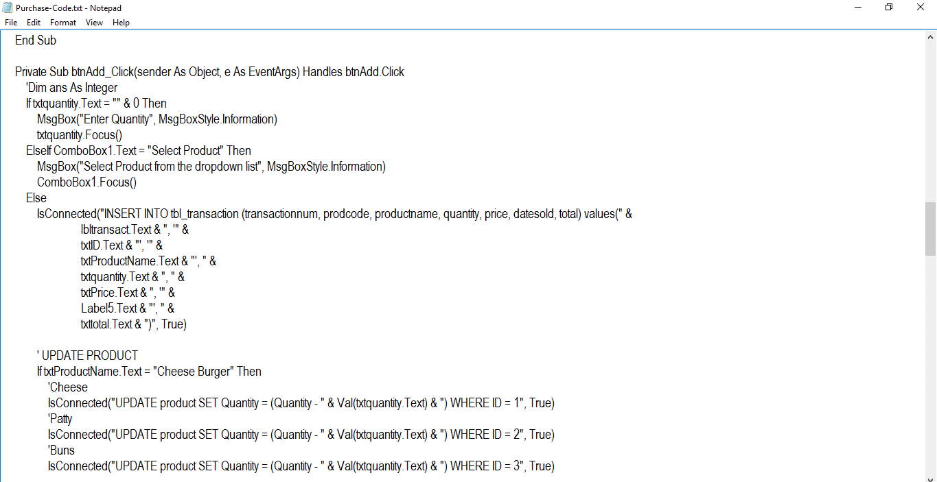

Purchase Code #4

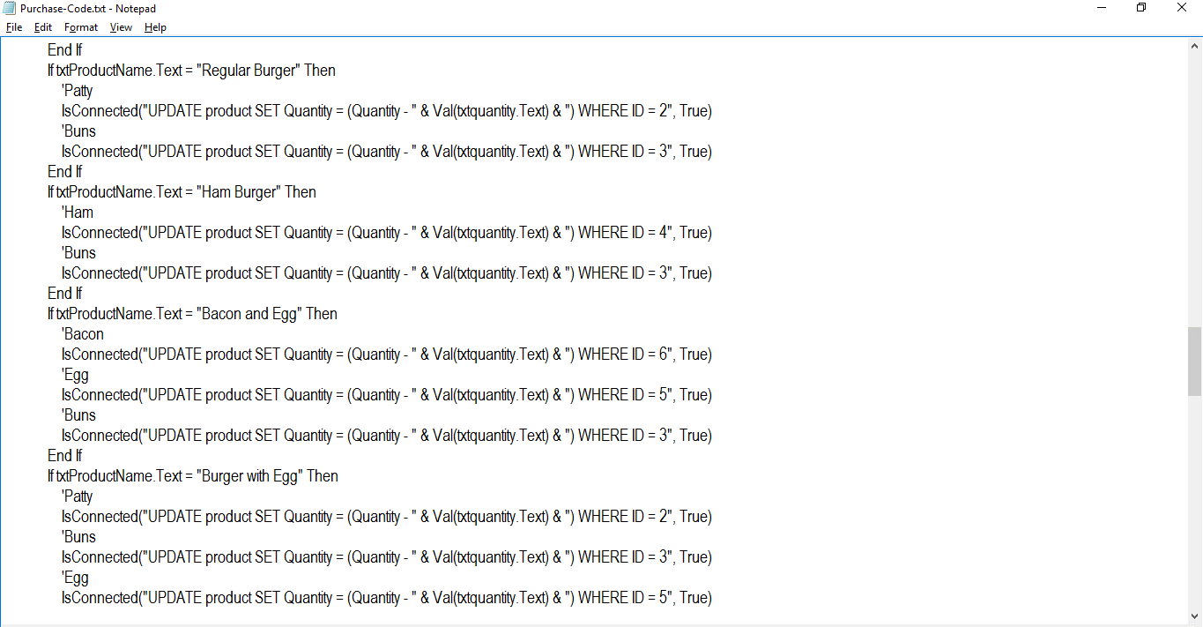

Purchase Code #5

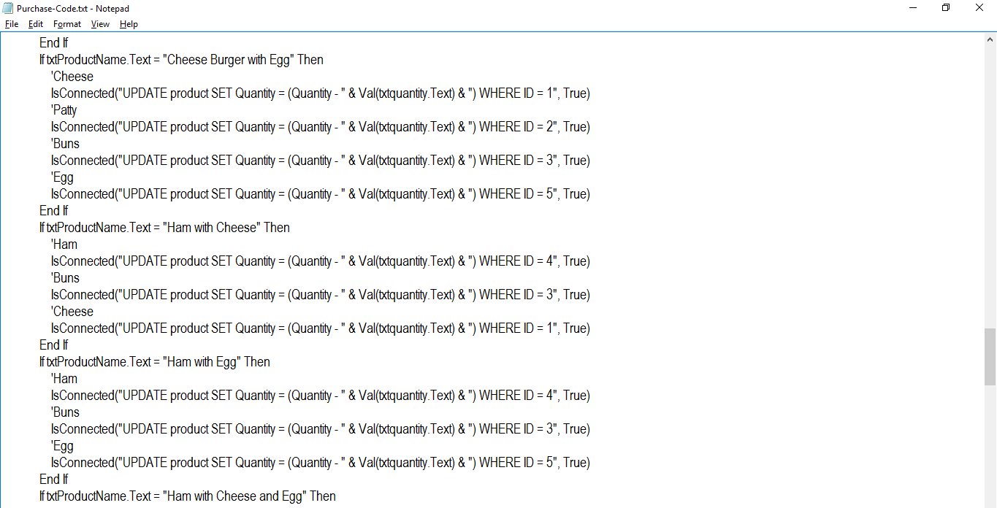

Purchase Code #6

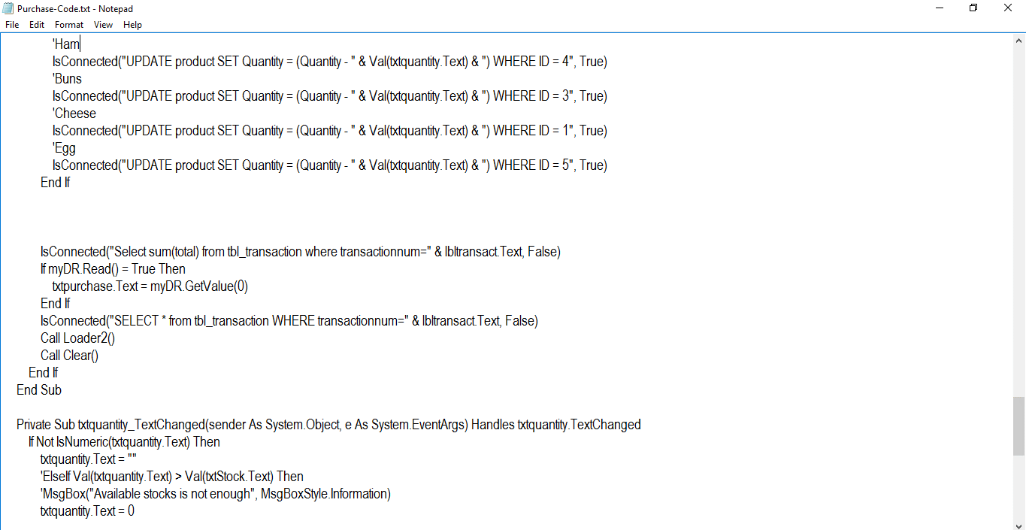

Purchase Code #7

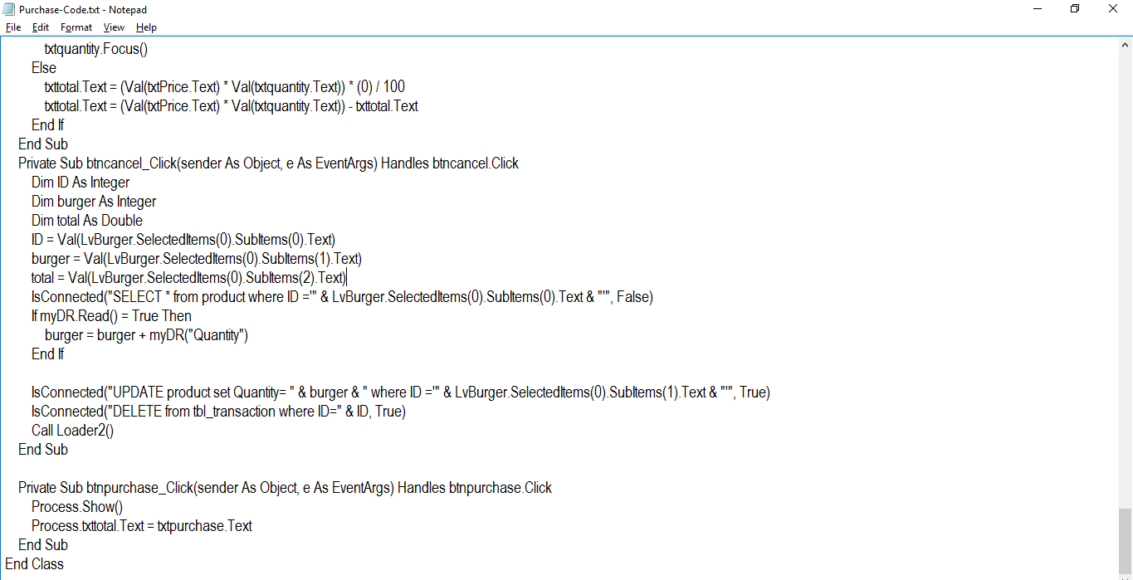

Purchase Code #8

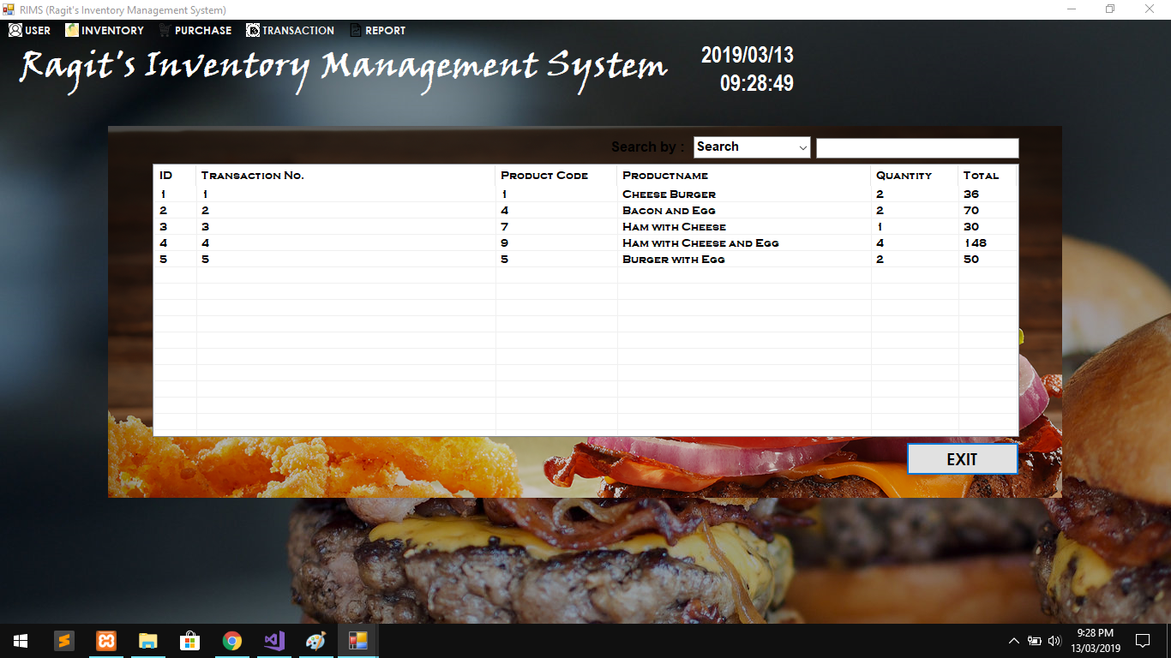

Transaction Form

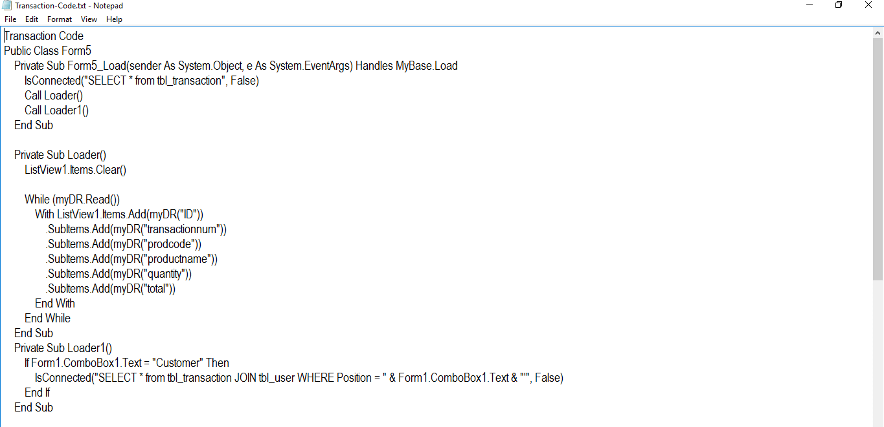

Transaction Code #1

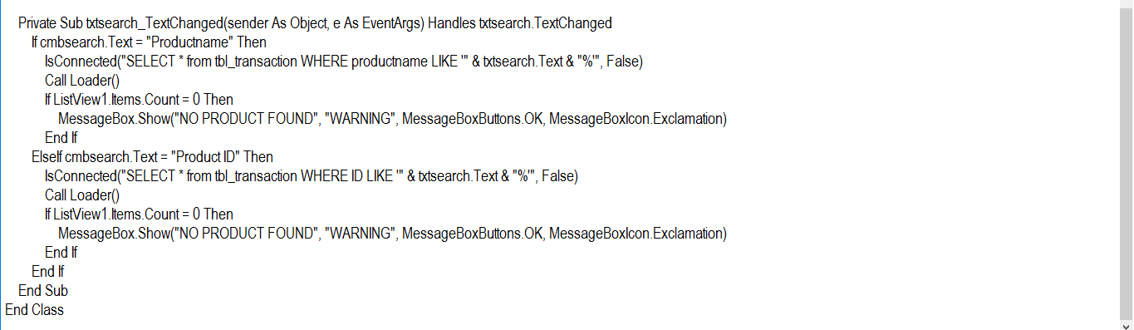

Transaction Code #2

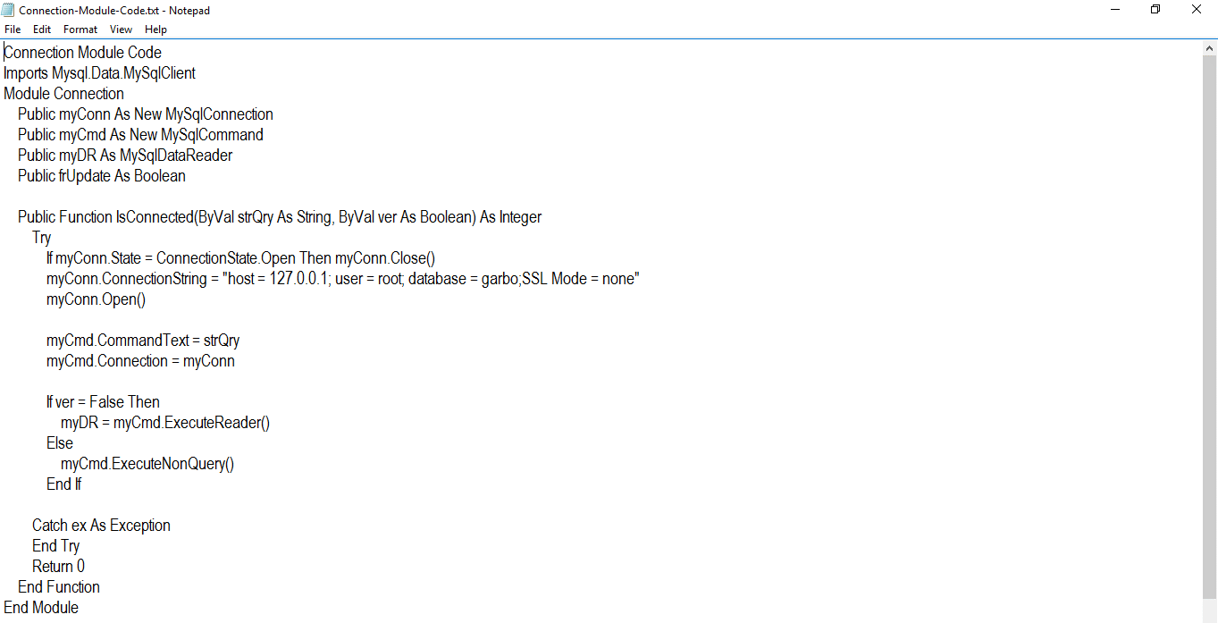

For The Connection

Chapter V

SUMMARY, CONCLUSIONS AND RECOMMENDATIONS

Summary

The inventory management system is good for the vendors as well as the customers as they can access the system anytime to browse and choose for the specific product that they want to buy. Ragit’s Burger Shop offers burger and fries and array of street foods. The shop maintained it’s reputation by providing clean foods and welcoming service that satisfies the needs of customers. The system helps the customers by manually inputting the product and employee’s information. Though the system, the user are secured clients in ordering products in Ragit’s Inventory Management.

Conclusion

The researcher conclude that the Inventory management system will lessen the task of researcher in conducting some study about the system. The system generates results automatically.

Recommendation

Based to the system that the proponents made, they recommended the following:

1. The future researchers must enhance of capability in adding some more features and process to it like:

a. Personal Information System Secured

b. User-friendly system

References

Bergin, Sarah. "Make Your Warehouse Deliver: New Developments in Warehouse Management Systems Inspire New Productivity in Needy Operations." *Transportation and Distribution,*February 1997

Betts, Mitch. "Manage My Inventory or Else!" *Computer-world,*31 January 1994.

Cecil Bozarth and Robert Handfield, **“Introduction to Operations and Supply Chain Management,”** Prentice-Hall, 2006. ISBN 0139446206.

Renny., Chandra, R., Ruhama, S., & Sarjono, M. W., (2013). Exploring Tracer Study Service in Career Center Web Site of Indonesia Higher Education. (IJCSIS) International Journal of Computer Science and Information Security, Vol. 11, No. 3

Quino, D. R., Emberda, E.J. (2013). Facebook Data Mining Application for an Automated Tracer Study. International Peer Reviewed Journal. Vol. 8

Udo, Godwin J. "The Impact of Telecommunications on Inventory Management." *Production and Inventory Management Journal,*spring 1993.



**Ragit’s Inventory Management System**

**(RIMS)**

A Research Paper Presented to the Dean of the

Department of Computer Studies

AMA Computer College

Lucena Campus

In Partial Fulfillment of the Requirements In the Subject

BY

Barola, Ron Ivan

Batilo, John Matthew

Cantos, Daniel

Ragit, Joshua

Ramos, Carl Garvie

February 2019